M.Niharika
2520090021
1

2
3

4
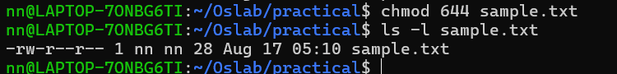
5
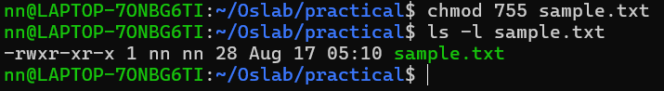
6
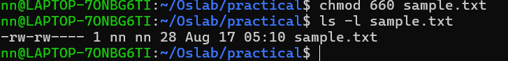
7
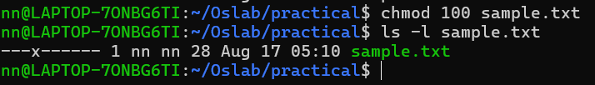

8-12

